
SERMON OUTLINE
Date: 19/10/2025 Preacher: Rev Dr Tan Yak Hwee
Text: Mark 14:43-72; Isaiah 53:4-6
Title: Entering/In the Courts of Fear...

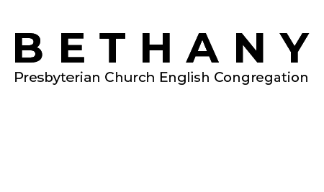
364A Upper Paya Lebar Road, Singapore 534965
8905 2640 | bethanypresbyterianenglish@gmail.com
BPCEC.ORG.SG

